Classroom TEAMS Rules
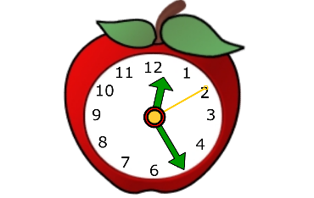

Show up a few minutes before class time and wait to be admitted into the class.

Find a quiet place free of distractions (siblings, television, parents, pets, etc.) Have your supplies ready.

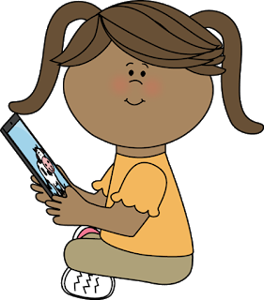

Be respectful at all times while your video is on. NO hand gestures and use kind language.

Stay on mute. Click the “raise hand” button if you have a question or something about the class to share.

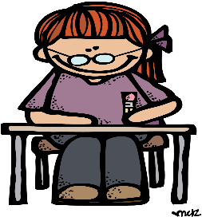

Stay focused and on task so you do not miss anything the teacher or your classmates say. (Use the restroom before class.)

